When working with groups – always set the group notification defaults to “Instantly.” The system defaults to “With My Digest” and you don’t want that.

This is what the screen looks like when you click on “Edit Group Notification Defaults”
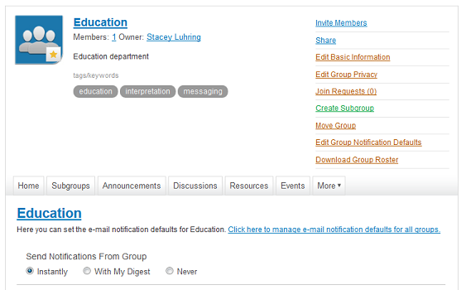

Click on the “Instantly” circle to change the defaults.

December 18, 2013

